# 1. INTRODUCTION

TechFlare is an online platform that offers a variety of IT courses designed to equip learners with the skills and knowledge needed to excel in the ever-evolving tech industry. The platform provides a comprehensive learning experience, allowing users to enroll in various courses ranging from basic programming to advanced data science and artificial intelligence.

A learning management system (LMS) like TechFlare offers a seamless and efficient way for students and professionals to access high-quality educational content. These systems typically feature an extensive course catalog, interactive learning modules, progress tracking, assessments, and certification upon completion. TechFlare's LMS incorporates cutting-edge technologies such as cloud computing and AI to deliver personalized learning experiences, adaptive learning paths, and real-time analytic to monitor learner progress.

In addition to providing core educational content, TechFlare also integrates with external resources like industry publications, tech forums, and major educational platforms, ensuring that learners have access to the latest trends and developments in the IT field. This integration helps keep the course material relevant and up-to-date, offering learners the best possible educational experience.

Overall, TechFlare's learning management system simplifies the learning process, making it more convenient and efficient for users to gain valuable IT skills. By leveraging advanced technology, TechFlare enhances both the learning experience and the overall efficiency of educational delivery, setting a new standard in online IT education.

# 2.OBJECTIVES

* + To provide high-quality, accessible IT courses for learners of all levels.
  + To create a community of learners and instructors to foster collaboration and networking.
  + To offer a user-friendly platform for course enrollment, access, and management.
  + To enhance the learning experience through interactive course materials and expert instruction.
  + To provide certification and recognition for course completion to enhance career opportunities.

# 3.SCOPE

* + The scope of TechFlare's IT courses includes:
  + Course enrollment and management.
  + Course materials access and interaction.
  + Progress tracking and certification.
  + Instructor-student interaction and collaboration.
  + Community building and networking.

# PROBLEM STATEMENT

* 1. The challenges faced by learners in accessing high-quality IT courses include limited availability, high costs, and lack of flexibility.
  2. Traditional learning methods may not be able to fulfill the diverse needs of learners, leading to sub-optimal learning experiences.
  3. TechFlare aims to address these challenges by providing affordable, flexible, and high-quality IT courses accessible to learners worldwide.

# 

# METHODOLOGY

* 1. TechFlare utilizes a blend of methodologies to deliver effective IT courses, including:
  2. Online lectures and tutorials.
  3. Interactive course materials.
  4. Hands-on projects and assignments.
  5. Real-world case studies.
  6. Quizzes and assessments.
  7. Discussion forums and live sessions.

**5.1 . Phases of Agile Methodologies:**

Following are the phases in the Agile model are as follows:

1. Requirements gathering

2. Design the requirements

3. Construction/ iteration

4. Testing/ Quality assurance

5. Deployment

6. Feedback

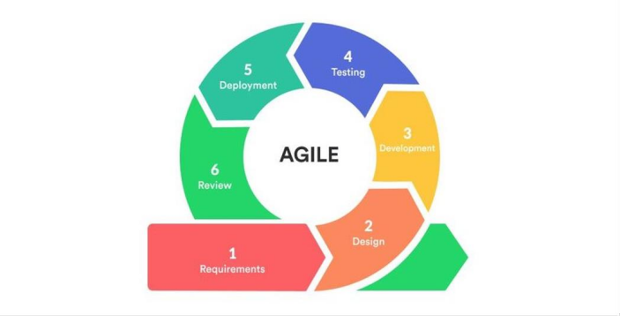

## Requirements Gathering:

Objective: Define the requirements for

the TechFlare IT website.

Activities: Identify business

opportunities and plan the necessary

time and effort. Evaluate the technical

and economic feasibility of the project.

Outcome: A detailed list of requirements

and an initial feasibility study

## Design the Requirements:

* Objective: Collaborate with stakeholders to define and design the requirements.
* Activities: Create user flow diagrams and high-level UML diagrams to illustrate the new features and their integration into the existing system.
* Outcome: A comprehensive design document detailing how the website will function and integrate with current systems.

## Construction/Iteration:

* Objective: Begin the actual development of the website.
* Activities: Designers and developers start building the project with a focus on deploying a functional product. The development process includes iterative improvements, starting with basic functionality and gradually adding more features.
* Outcome: An initial version of the website with core functionalities, ready for further enhancements.

## Testing/Quality Assurance:

* Objective: Ensure the website meets quality standards.
* Activities: The Quality Assurance (QA) team tests the product for performance issues and bugs. Various testing methods, including automated and manual testing, are employed to ensure the website functions correctly.
* Outcome: A bug-free, high-performing website ready for deployment.

## Deployment:

* Objective: Release the website to the users.
* Activities: Deploy the website to the production environment, making it accessible to users.
* Outcome: The website is live and available for users to access various IT courses.

## Feedback:

* Objective: Gather user feedback to improve the website.
* Activities: Collect feedback from users regarding their experience with the website. Analyze the feedback to identify areas for improvement and implement necessary changes.
* Outcome: Continuous improvement of the website based on user feedback, ensuring it meets user needs and expectations.

# Data Flow Diagram.

# Picture

# **Use Case.**

# 

# 

# WPS Photos(1)

# TIMELINE/ MILESTONE

The development and implementation of TechFlare's IT courses will be carried out over a period of six months, with the following milestones:

* 1. Month 1-2: Course development and content creation.
  2. Month 3-4: Platform development and testing.
  3. Month 5-6: Course launch and promotion.

# EXPECTED OUTCOMES

TechFlare aims to achieve the following outcomes:

* 1. Increased accessibility to high-quality IT courses.
  2. Enhanced learning experiences through interactive and engaging content.
  3. Improved skills and knowledge in various IT domains.
  4. Career advancement opportunities through certification and recognition

# TECHNOLOGY

* 1. Front-End:
  2. React.js: For building a responsive and interactive user interface.
  3. Java-Script for extra features.
  4. HTML5/CSS: For structuring and styling the web pages.
  5. Bootstrap: For responsive design and ease of styling.

# FUNCTIONAL REQUIREMENTS

### User Registration and Authentication

* + Enable user account creation and login via email and social media (Google, Facebook).

### Course Catalog and Enrollment

* + Provide a searchable and filterable course catalog.
  + Allow users to enroll in courses and track their enrollment status.

### Online Payment Processing

* + Support secure payments via credit/debit cards and PayPal.

### Course Content Delivery

* + Provide access to course materials (videos, readings, quizzes, assignments) for enrolled users.

### Progress Tracking and Certification

* + Show user progress indicators for each course.
  + Generate digital certificates upon course completion.

# DELIVERABLES

* 1. Fully functional Learning Management System (LMS).
  2. High-quality IT courses with interactive course materials.
  3. Certification and recognition for course completion.
  4. Community platform for learners and instructors.

# RISKS AND CHALLENGES

* 1. Technical challenges in platform development and maintenance.
  2. User adoption and engagement.
  3. Competition from other online learning platforms.
  4. Ensuring course quality.

# Reference

* Java point retrieved 2024, from <https://www.javatpoint.com/software-engineering-agilemodel>
* GeeksforGeeks 2024, from <https://www.geeksforgeeks.org/article-url/>